# Installation

1. Download FFMpeg from <https://ffmpeg.org/download.html> by obtaining the package for your operating system from the "Get packages & executable files" section

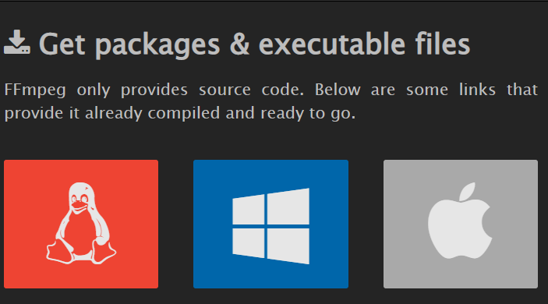

1. Install both the conversion script and ffmpeg to your Maya "scripts" folder. On Windows, ffmpeg should be in a folder named "ffmpeg", on MacOS this will just be a single executable.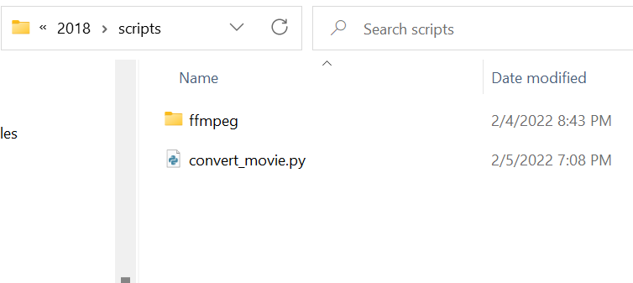
2. Create a shelf button and assign the following commands to it: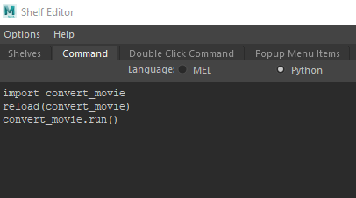

import convert_movie

reload(convert_movie)

convert_movie.run()

1. The tool can now be opened by clicking on the shelf button.

# Usage

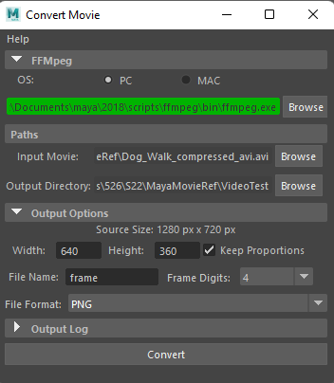

1. After clicking on the shelf button you should see a user interface as above.
2. If the FFMpeg text box is red, click the "Browse" button to locate the ffmpeg.exe (on Windows) or ffmpeg (on MacOS). Otherwise the text box will be green and you are good to go.
3. Specify the input/output paths
   * Input is a movie (click Browse and locate the .avi, .mp4, etc.). You can also specify an image sequence as input by choosing one of the images part of the sequence.
   * Output is a directory where to place the movie frame images
4. Adjust output options if needed:
   * Width/height configures the size of the output images
   * File Name configures the start of the name of each output image file
   * Frame Digits specifies how many digits to have in the frame number of the image (e.g. 4 digits would be "0001", 3 digits "001", etc.)
   * File format can be switched to JPEG if needed, otherwise leaving it as PNG will be sufficient.
   * You also have the option of outputting an MP4 or AVI if needed.
5. Click the Convert button.
6. After the process completes, a prompt will appear notifying the conversion was successful, and the output directory will now contain the sequence of frames of the movie.